Thermal hotspots.

https://developers.google.com/earth-engine/guides/image_objects#code-editor-javascript

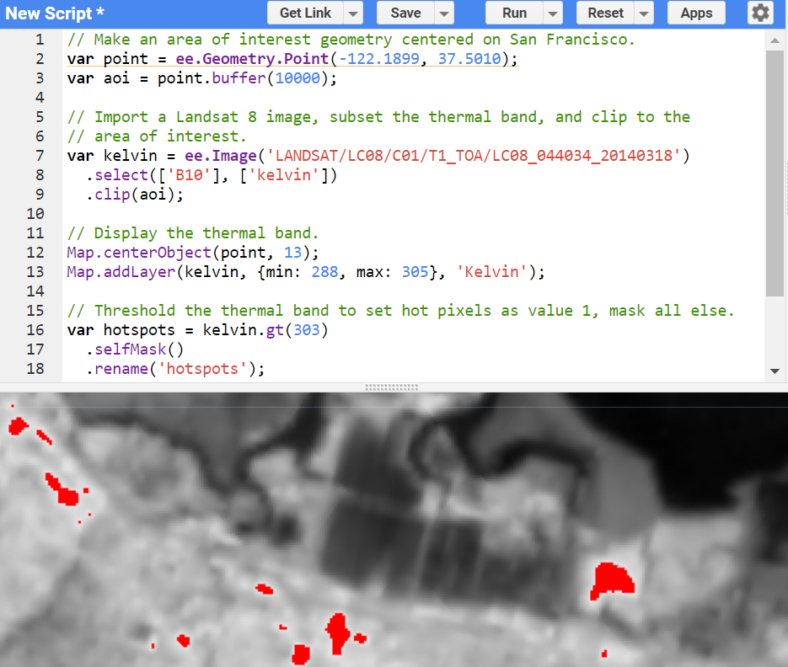

Figure 1. Temperature for a region of San Francisco. Pixels with temperature greater than 303 degrees Kelvin are distinguished by the color red (thermal hotspots).

// Make an area of interest geometry centered on San Francisco.

var point = ee.Geometry.Point(-122.1899, 37.5010);

var aoi = point.buffer(10000);

// Import a Landsat 8 image, subset the thermal band, and clip to the

// area of interest.

var kelvin = ee.Image('LANDSAT/LC08/C01/T1_TOA/LC08_044034_20140318')

.select(['B10'], ['kelvin'])

.clip(aoi);

// Display the thermal band.

Map.centerObject(point, 13);

Map.addLayer(kelvin, {min: 288, max: 305}, 'Kelvin');

// Threshold the thermal band to set hot pixels as value 1, mask all else.

var hotspots = kelvin.gt(303)

.selfMask()

.rename('hotspots');

// Display the thermal hotspots on the Map.

Map.addLayer(hotspots, {palette: 'FF0000'}, 'Hotspots');